Tommy Tran

Vistas in Advanced Computing

10 August 2018

Supervised by Dr. Pengzhi Zhang

Hydrogen(H2) Simulation

Molecular Dynamics simulations allow us to experiment on the microscopic level and see how this data corresponds with macroscopic data taken from a laboratory experiment. This MD simulation is of the Hydrogen molecule (H-H).

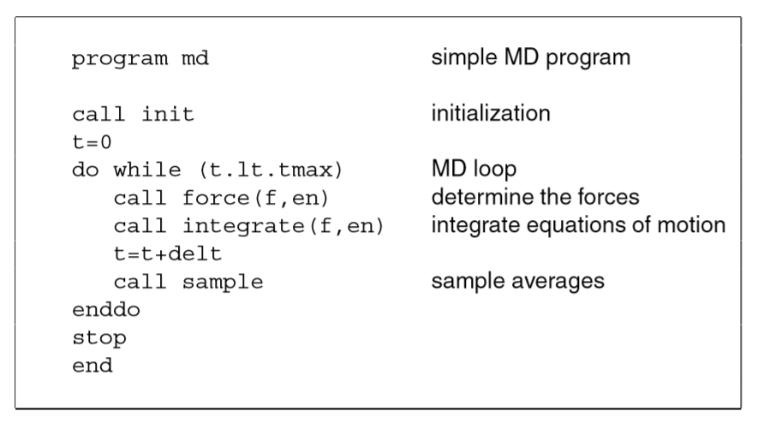

The basic structure of the MD code I wrote is based on the presentation notes given by Dr. Pengzhi Zhang. The code consists of an initialization function that puts the number of atoms in a 3-D lattice. Also, something to note is that this simulation only works on an even number of atoms. If “n” (the length of a side of the box) is an odd number, I would get an odd number of atoms once “n” is cubed. That means I would have a lone hydrogen atom floating around, which won’t work. The initialization function also assigns random velocities to each atom with a value between 0 and 1. The algorithm for determine an atom’s position in the lattice is pasted below, along with how the lattice should look like once visualized in VMD.

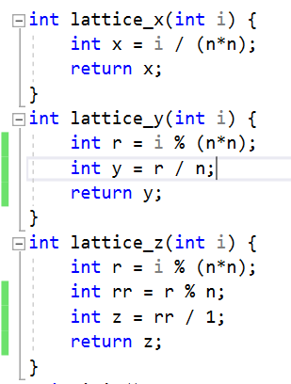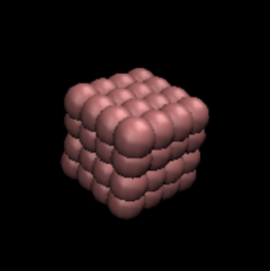

The while loop consists of a force function and integration function which calculates the force and the next position. The Lennard-Jones Potential is used to approximate interactions between neutral atoms or molecules. The Lennard-Jones Potential is in units of energy. Taking the derivate of the Lennard-Jones Potential with respect to the position of the atom gives the instantaneous force on that atom.

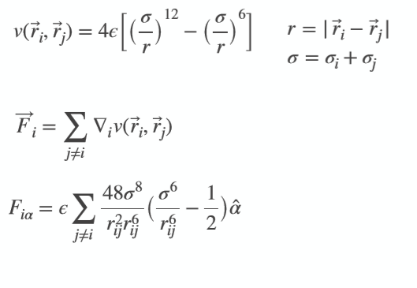

Another force to consider is the bonding force between atoms in the hydrogen molecule. Using the energy of a spring equation or harmonic potential equation, taking the partial derivate with respect to x,y,z position gives the instantaneous force experienced by the respective atom you are integrating for. The harmonic potential equation as well as the derivations of bonding force from the harmonic potential are posted down below.

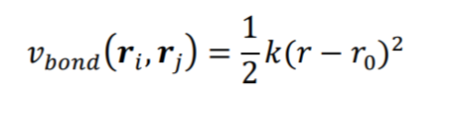

r0 - equilibrium bond length constant (search up for Hydrogen molecule)

k - spring constant

dE/dxi = ½ \* k(2xi-2xj) - ( r0(2xi-2xj)/r )

dE/dxj = ½ \* k(2xj-2xi) - ( r0(2xj-2xi)/r )

dE/dyi = ½ \* k(2yi-2yj) - ( r0(2yi-2yj)/r )

dE/dyj = ½ \* k(2yj-2yi) - ( r0(2yj-2yi)/r )

dE/dzi = ½ \* k(2zi-2zj) - ( r0(2zi-2zj)/r )

dE/dzj = ½ \* k(2zj-2zi) - ( r0(2zj-2zi)/r )

r = √(xi-xj)^2+(yi-yj)^2+(zi-zj)^2

Dr. Pengzhi Zhang advised me to look up the k constant for a hydrogen molecule in some book or research paper online, but I could not find it. I just plugged in random values such as 1, 100, 1000, and saw which one worked best, or at least looked like a diatomic molecule floating around. I stuck with 100 because everything seemed to work moderately. The bonding force between two atoms is an action-reaction described by Isaac Newton’s Three Laws of Motion. After calculating bond forces in hydrogen molecules, the derivative of the Lennard-Jones Potential (force) is calculating between every single surrounding atom in the system.

There is of course a boundary condition to determine how far an atom must be from the reference atom to have an effective force between both atoms.

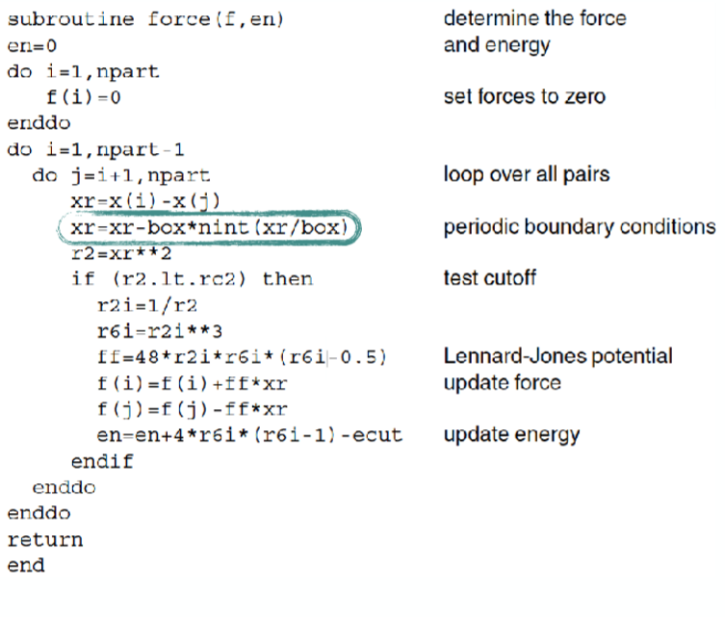

Provided below is the C++ code:

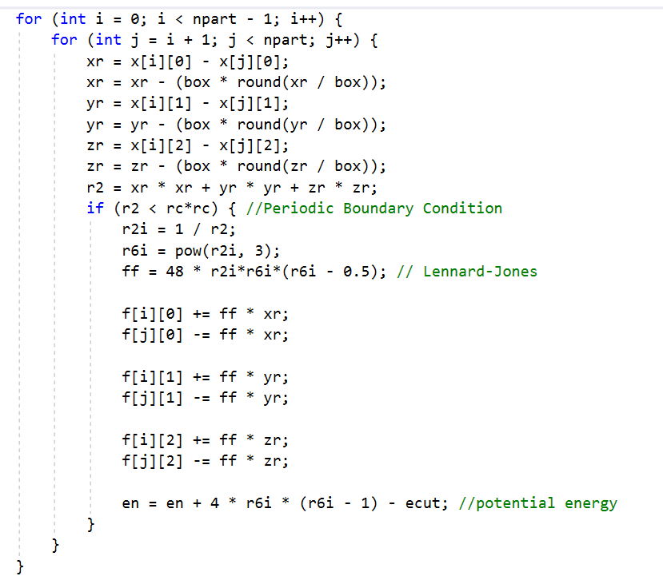

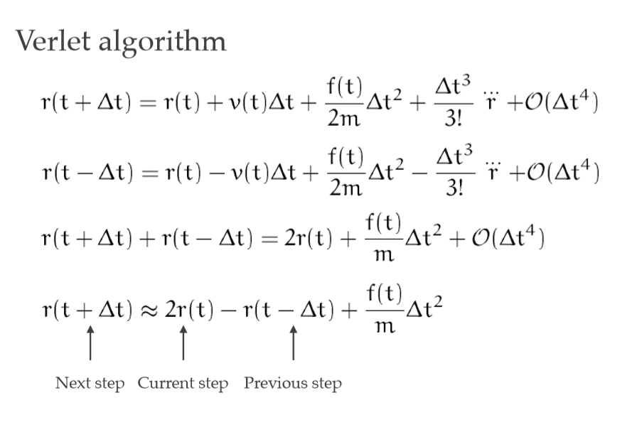

This simulation can actually be applied to almost any neutral diatomic molecule, such as O2(O-O) or F2(F-F). All one needs to do is change the sigma(radius of atom), k constant (spring constant), r0 (equilibrium bond length), and any other parameters that will help represent whichever molecule one is trying to simulate. I don’t know how accurate all of this is, but it is definitely something.